**MARKET BASKET ANALYSIS**

A project report submitted for pre-final year of

**Bachelor of Technology**

in

**Computer Science and Engineering**

By

Reshma (N130954)

*Under the Supervision of*

**Mr . K K SINGH**



**Department of Computer Science and Engineering**

**Rajiv Gandhi University of Knowledge Technologies – Nuzvid**

**Nuzvid, Krishna – 521202**

August, 2018

**--------------------------------------------------------------------------------------------------------------------------------------**

**Rajiv Gandhi University of Knowledge Technologies**

**(A.P. Government Act 18 of 2008)**

**RGUKT-NUZVID, Krishna Dist - 521202**

Tele Fax: 08656 – 235557/235150

## CERTIFICATE OF COMPLETION

This is to certify that the work entitled, “**Market Basket Analysis**”is the bonafied work of ***Reshma , ID No: N130954*** carried out under my guidance and supervision for pre final year project of **Bachelor of Technology** in the department of Computer Science and Engineering under RGUKT IIIT Nuzvid. This work is done during the academic session June2018 – July2018, under our guidance.

­­

---------------------------- ---------------------------

**Mr. K.K SINGH Mr.UPENDRA**

Project SupervisorHead of Department

Lecturer Dept. of CSE Assistant Professor Dept. of CSE

RGUKT IIIT Nuzvid, Nuzvid RGUKT IIIT Nuzvid, Nuzvid

**--------------------------------------------------------------------------------------------------------------------------------------**

**Rajiv Gandhi University of Knowledge Technologies**

**(A.P. Government Act 18 of 2008)**

**RGUKT-NUZVID, Krishna Dist - 521202**

Tele Fax : 08656 – 235557/235150

## CERTIFICATE OF EXAMINATION

This is to certify that the work entitled, “**Market Basket Analysis”** is the bonafied work of ***Reshma, ID No: N130954*** and here by accord our approval of it as a study carried out and presented in a manner required for its acceptance in pre final year of **Bachelor of Technology** for which it has been submitted. This approval does not necessarily endorse or accept every statement made, opinion expressed or conclusion drawn, as a recorded in this thesis. It only signifies the acceptance of this thesis for the purpose for which it has been submitted.

­­

---------------------------- ---------------------------

**Mr .K.K SINGH Examiner**

Project SupervisorProject Examiner

Lecturer Dept. of CSE Lecturer Dept. of CSE

RGUKT IIIT Nuzvid, Nuzvid RGUKT IIIT Nuzvid, Nuzvid

**--------------------------------------------------------------------------------------------------------------------------------------**

**Rajiv Gandhi University of Knowledge Technologies**

**(A.P. Government Act 18 of 2008)**

**RGUKT-NUZVID, Krishna Dist - 521202**

Tele Fax: 08656 – 235557/235150

## DECLARATION

I, ***Reshma, ID No: N130954*** hereby declare that the project report entitle “**Market Basket Analysis”** done by us under the guidance of **Mr. K.K SINGH p.hd.,** is submitted for pre final year of **Bachelor of Technology** in **Computer Science and Engineering** the academic session June2018-July 2018 at RGUKT– Nuzvid.

We also declare that this project is a result of our own effort and has not been copied or imitated from any source. Citations from any websites are mentioned in the references.

The results embodied in this project report have not been submitted to any other university or institute for the award of any degree or diploma.

­­

**Date:1-08-2018**

**Place: Nuzvid Reshma [N130954]**

**ACKNOWLEDGEMENT**

I would like to express our profound gratitude and deep regards to my guide ***Mr. K.K SINGH*** for her exemplary guidance, monitoring and constant encouragement throughout the course of this thesis.

I am extremely grateful for the confidence bestowed in us and entrusting our project entitled “Market Basket Analysis”.

At this juncture we feel deeply honored in expressing our sincere thanks to him for making the resources available at right time and providing valuable insights leading to the successful completion of my project.

We would like to thank RGUKT Nuzvid Director, faculty and staff for their valuable suggestions and discussions.

Reshma

**ABSTRACT**

Market Basket Analysis is a modelling technique based upon the theory that if you buy a certain group of items, you are more (or less) likely to buy another group of items. The main aim of MBA in marketing is to provide the information to the retailer to understand the purchase behavior of the buyer, which can help the retailer in correct decision making. There are various algorithms are available for performing MBA.

Today, the large amount of data is being maintained in the databases in various fields like retail markets, banking sector, medical field etc. But it is not necessary that the whole information is useful for the user. That is why, it is very important to extract the useful information from large amount of data. This process of extracting useful data is known as data mining or A Knowledge Discovery and Data (KDD) process.

In this project I have collected products transactions report and applied apriori algorithm to find frequent item sets.

**CONTENTS**

**I .Chapter 1**

1. **Introduction** ……………………………………………... 08
   1. Introduction ………………
   2. Importance of Market Basket Analysis……………………………… 09

**II. Chapter 2**

2.1 Algorithm

2.2 Example

2.3 Input and Output

* 1. Advantages and Disadvantages
  2. Applications…………….
  3. Conclusion and Future Scope…………

2.7 References…………………

**CHAPTER 1**

* 1. **INTRODUCTION**

Market Basket Analysis (Association Rule Mining) is a mathematical modelling technique in data mining. Today, the large amount of data is being maintained in the databases in various fields like markets, banking sector, medical field etc.

But it is not necessary that the whole information is useful for the user. That is why, it is very important to extract the useful information from large amount of data. This process of extracting useful data is known as data mining.

It helps the marketing analyst to understand the behavior of customers e.g. which products are being bought together . A large number of people use to visit shopping malls and shopping centers .Massive amounts of data continuously being collected and stored as transactions.

The availability of detailed information on customer transactions has led to the development of techniques that automatically look for associations between items that are stored in the database . Those collected data can be useful from the business prospective such as bio-informatics , finance , banking-sectors etc .

* 1. IMPORTANCE

1. Market Basket Analysis helps the store owner in store arrangement.

This led to increase the revenue of the store.

1. Market Basket Analysis can improve the efficiency of the delivery of order(whether email , mobile , social media etc..,) by the customers.
2. It helps in placing the contents in a certain order that help boost conversions.
3. It help companies especially retailers , to analyse buying behaviour and predict their next purchase.

CHAPTER 2

* 1. ALGORITHM

Apriori algorithm is the most established algorithm for finding frequent item sets mining.

The basic principle of Apriori is “Any subset of a frequent itemset must be frequent”.

We use these frequent item sets to generate association rules.

An Apriori algorithm is used to find association rules between different product categories.

* 1. EXAMPLE

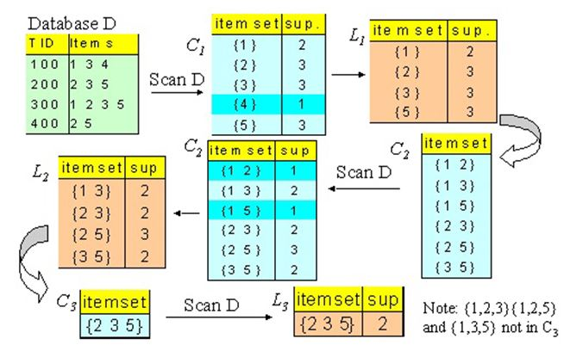

2.3 INPUT AND OUTPUT

Input :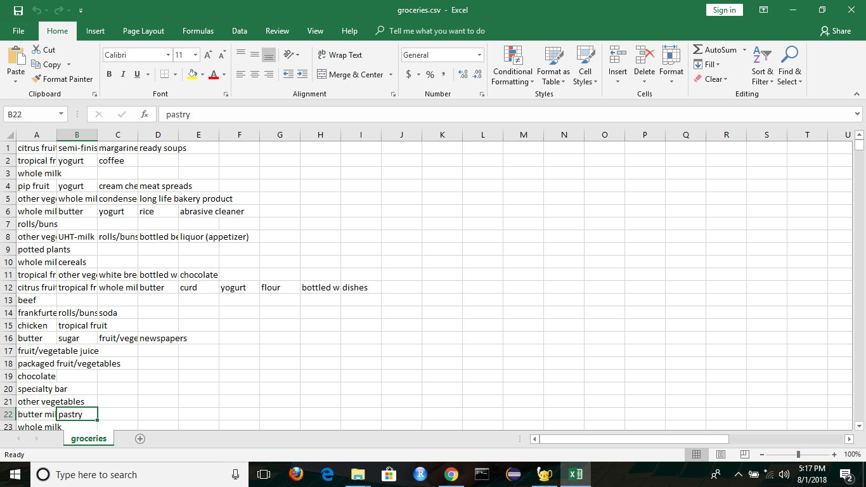

Output :

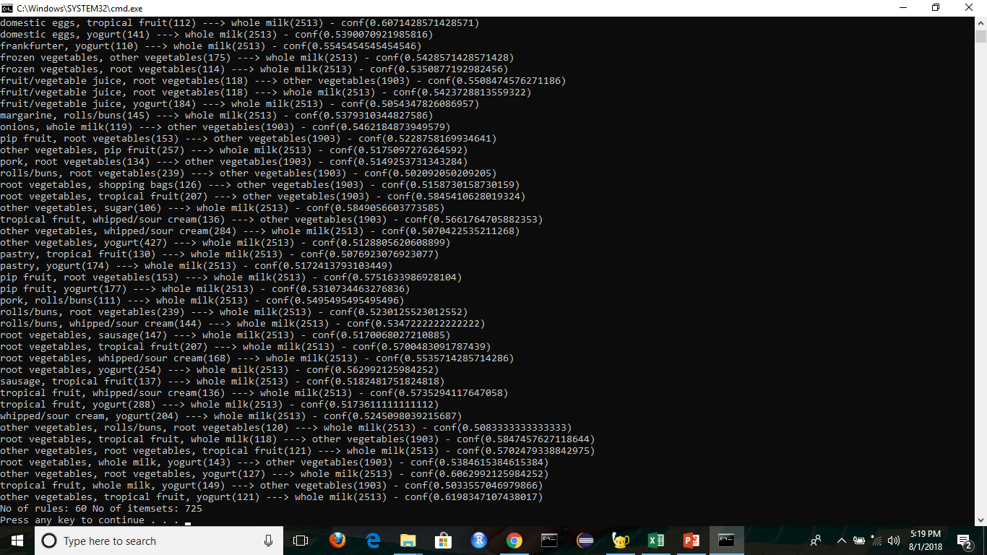

* 1. ADVANTAGES AND DISADVANTAGES

Advantages:

Apriori algorithm works well and will not cause any issue just because it considers A->B and B->A as same because this is an approach used for cross-selling the products based on the market based analysis.

Disadvantages:

The primary limitation of apriori algorithm is the efficiency.

Apriori algorithm may become really slow especially when there are more candidates to analyze.

* 1. Applications

1.Cross selling of the items.

2.Proper placement of items

3.Fraud Detection and

4. Customer behaviour

2.6 Conclusion And Future Scope

Conclusion:

It is an approach to association rule mining in multiple store environment.

We have shown how Market basket analysis using association rules works in determining the customer buying patterns.

Future Scope:

The future work would be some modification of other algorithms to generate the association rules that can be adopted on existing recommendation system to make them functionally more effective.

Better and effective rule mining techniques can be used for better performance of the recommendation system. Effective Neural Network techniques can be incorporated with the Association Rule Mining to increase the accuracy of the recommendation system.

References

🡪Stack Overflow

🡪GitHub.com

🡪pypi.python.org/pypi/sumy

🡪www.dev.to